Lab 4 – Projectile Motion
Video URL link: https://www.youtube.com/watch?v=BriazLkgXa4&list=PLLF2jNBy_OPumuv2eSvIbvnDDfQj0cGEU&index=2
All entries should have base SI units
Show all calculation steps
In-person Instructions
- Level the apparatus with bubble level
- Move apparatus so it is flush with the table’s edge
- Measure dimension data
- Record data for 10 trials
- Number each trial on the impact sheet
  - Take a picture and include in the submitted assignment
- Record data for 10 trials
- Report the initial velocity with appropriate uncertainty

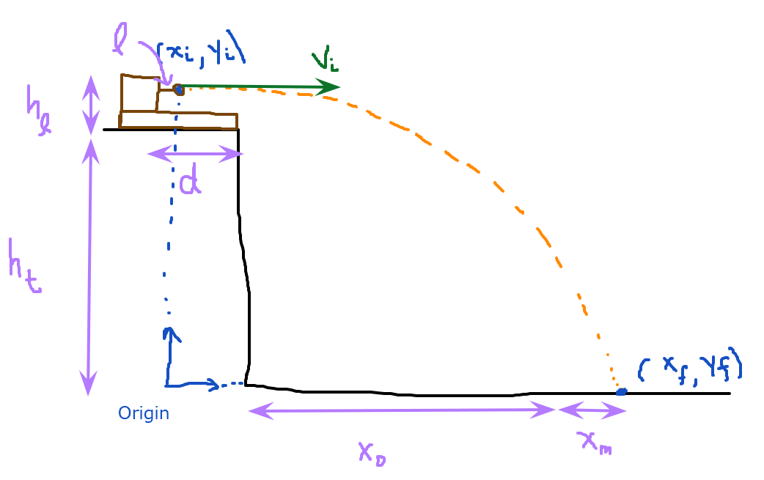

Length of launcher $(l)$ | 7.1 cm
Distance to edge of table $(d)$ | 34.2 cm
Table and platform height $(h_{t})$ | 80.5 cm
Launcher height $(h_{l})$ | 7.5 cm
Paper position $(x_{0})$ | 175.1 cm

Initial position $(x_{i})$ | 0
Initial vertical position $(y_{i}=h_{t}+h_{l})$ | 88 cm
Final vertical position $(y_{f})$ | 0
Initial vertical velocity $(v_{iy})$ | 0 ? not sure

Trial number | Measured data  $$x_{m}$$ | Calculated column  $$x_{f}=\left(d-l\right)+x_{0}+x_{m}$$
1 | 11.3 cm
2 | 12.2 cm
3 | 12.7 cm
4 | 13 cm
5 | 14.4 cm
6 | 13.2 cm
7 | 14.7 cm
8 | 11.3 cm
9 | 9.6 cm
10 | 10.4 cm

If you are in-person, copy a photo of your impact sheet here (with each trial number labeled)

Mean of x_{f} | Standard Deviation | 2σ

Derive an equation to predict initial velocity in terms of measured quantities $x_{f}$, $g=-9.8\frac{m}{s^{2}}$, and $y_{i}$ by plugging in known initial/final conditions and combining the following two equations:
$$x_{f}=v_{ix}t+x_{i}$$
$$y_{f}=\frac{1}{2}gt^{2}+v_{iy}t+y_{i}$$

By applying the method of adding percent uncertainty you would get the following equation. Note that$δx_{m}=2σ$ from above and $δy=0.001 m$.
$$\frac{δv_{i}}{v_{i}}=\frac{1}{2}\left(2\frac{δx_{f}}{x_{f}}+\frac{δy}{y}\right)$$

Report your initial velocity in the form $v_{i}±δv_{i}$.
Initial velocity

